# Extender prediction

## Introduction

device_score = 0.5*poor_rssi +0.5*poor_phyrate

Figure WiFi Score

This project aims to develop a predictive model for recommending extenders to customers based on potential improvements in their WiFi performance using a proprietary metric termed the “**WiFi-score**”. (WiFi score is defined as show in Figure 1)

In essence, if there is a high **likelihood** that a customer will attain a higher WiFi score following the installation of a WiFi extender, we advocate for proceeding with the installation. This **probability** of achieving WiFi improvement is deemed as the **extender score**.

By leveraging historical WiFi related KPIs (rssi, phyrate and data usage, etc.) and machine learning techniques, our model will offer personalized recommendation and provide better user experience.

## Step 1: Model Development

1. Collect data from homes recently installed extenders, including WiFi KPIs and WiFi-scores (KPIs would be the feature of model, WiFi-Score increment would be the target of model).

This dataset include n-days before and after the installation of extender, allowing for a comprehensive comparison of WiFi performance before and after the intervention.

1. Use this data to build a predictive model that identifies attributes of families   
   exhibiting significant WiFi performance enhancement after installing extender.

## Step 2: Model Application and Recommendation

1. Apply the developed model to families that currently only have a router, to predict potential WiFi performance improvements if they were to install an extender.
2. Based on the model’s predictions, recommend extenders to families with potential improvement

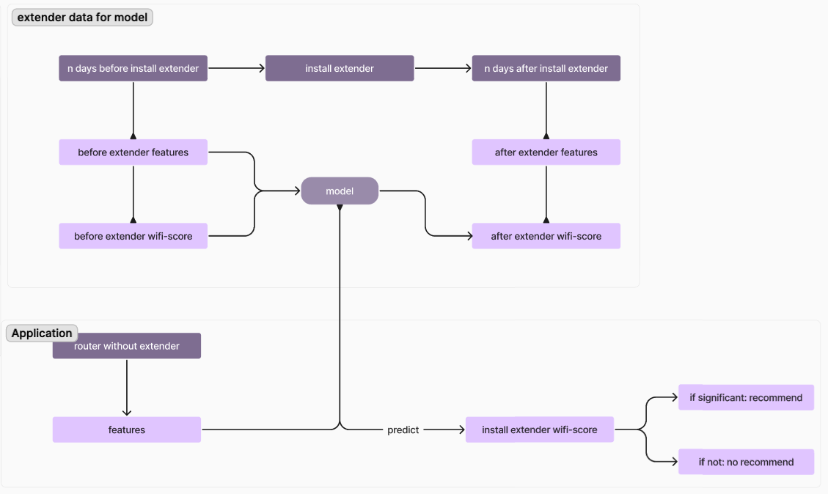

### *Assumption

To make our predictive model useful for many homes, it is important that extender data-which we use to build the model- accurately represent the variety of all router families.   
This means the extender data should be a random sample from the entire population.

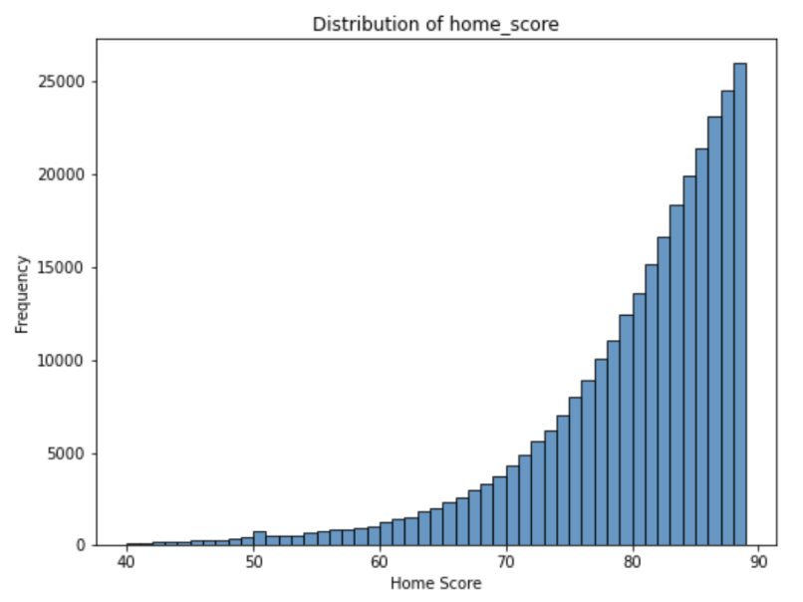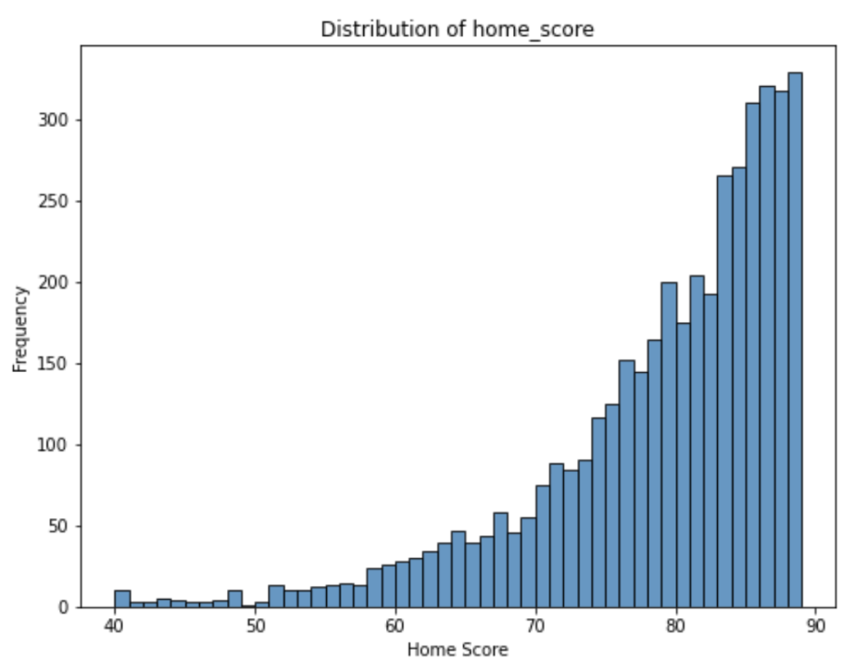

## Model Description

The model aims to predict a binary outcome (enhance_flag), which is associated with reaching a threshold.

### Features

* signal strength categories (avg_sig_strength_cat1, avg_sig_strength_cat2, avg_phyrate),
* home score metrics (before_home_score, after_home_score)
* network performance indicators (poor_phyrate, poor_rssi).
* score_increment feature, calculating the difference between after_home_score and before_home_score, and categorizing signal strengths into bins.

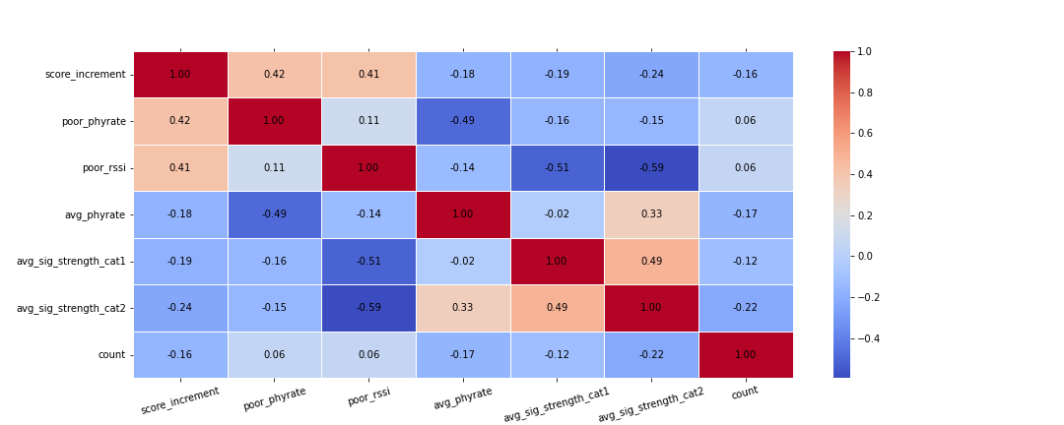

### Mode Parameters

Two models are developed with respect to different definition of WiFi enhancement.

1. The first one regard any **positive wifi-score** enhancement as WiFi enhancement;
2. the second one regard any **larger than 5 wifi-score** enhancement as WiFi enhancement

Both two models use RandomForestClassifier, trained with parameters like:

* n_estimators=50,
* max_depth=5,
* min_samples_split=10,
* min_samples_leaf=5
* class weights adjusted to balance the dataset.

# Model Evaluation

|  |  |
| --- | --- |
| score_increment > 0 | score_increment > 5 |
|  |  |
|  |  |
| Test Accuracy: 0.72  **Precision (Revers Cost): 0.79**  **Recall (Profit): 0.76**  True Negative Rate: 0.62  False Negative Rate: 0.66 | Test Accuracy: 0.8  **Precision (Revers Cost): 0.69**  **Recall (Profit): 0.68**  True Negative Rate: 0.85  False Negative Rate: 0.86 |
| score_increment > 0 | |
| score_increment > 5 | |
| More difficult to predict positive: score_increment > 5 has less positive than score_increment > 0  More confident the predict positive home is going to have better WiFi experience | |
|  |  |